

Artificial Intelligence Lab 07 Tasks

**Name:** Maryam Malik

**Sap ID: 45369**

**Batch:** BSCS-6th semester **Lab Instructor:** Ayesha Akram

**Task1. Solution:**

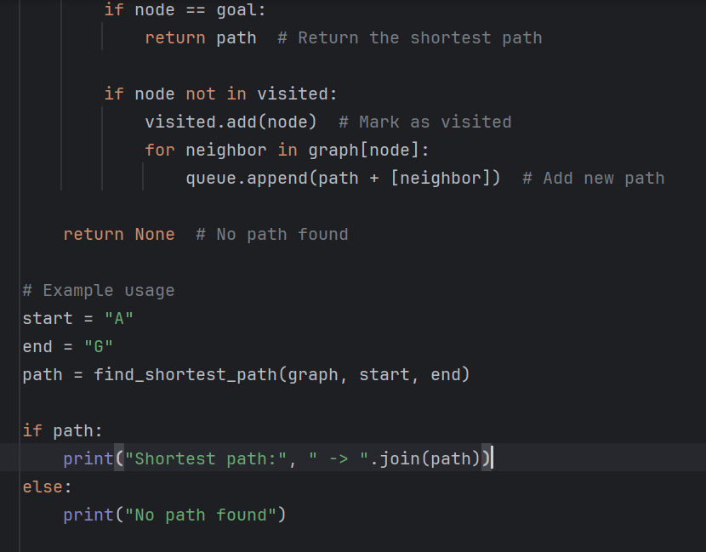

**Task2. Solution:**

**Task3. Solution:**

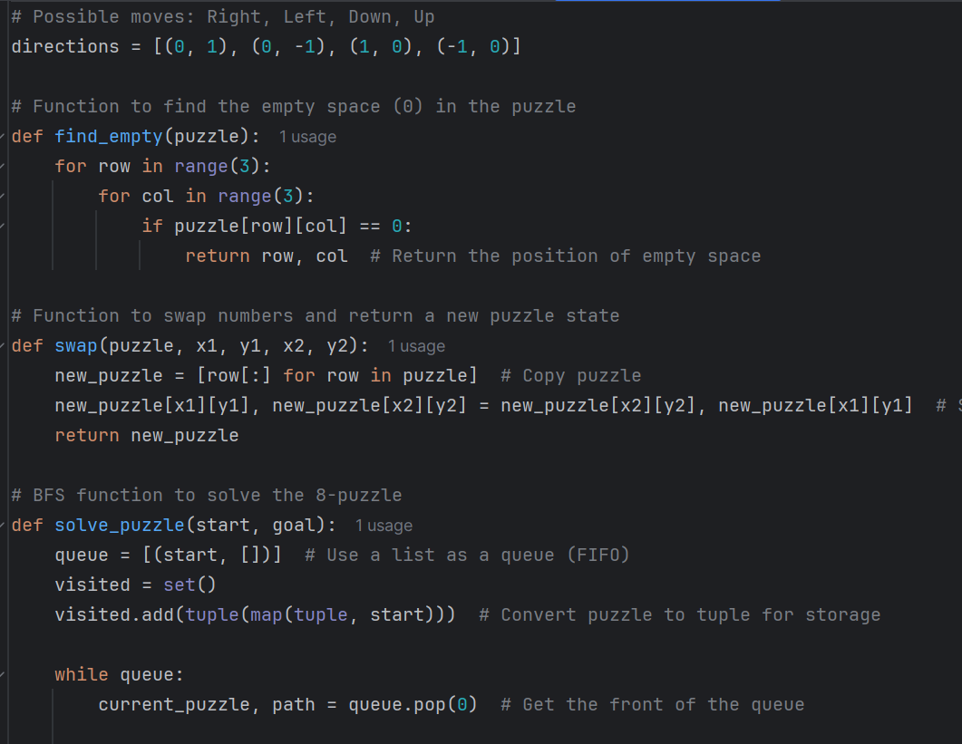

**Task4. Solution:**

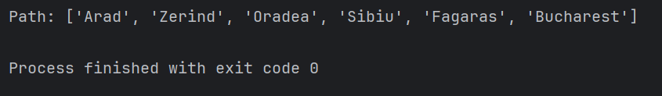

**Task5: Solution:**

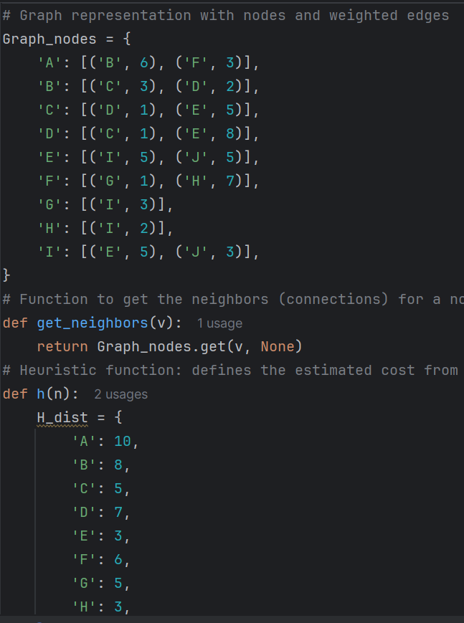

**Task6: Solution:**



